Customer Shopping Trend Analysis

Project Overview
This analytical initiative is focused on leveraging 3,500 transactional records to understand core drivers of sales performance and customer retention. The primary objective is to dissect purchase behaviors, with a special emphasis on identifying high-value customer segments, evaluating the effectiveness of the current subscription model, and providing actionable insights to optimize marketing spend and product placement for sustained revenue growth.

Dataset Summary
  - Rows: 3,500
  - Columns: 18
  - Missing Data: 37 values in Review Rating column
  - Key Features:
- Customer demographics (Age, Gender, Location, Subscription Status)
- Purchase details (Item Purchased, Category, Purchase Amount, Season, Size, Color)
- Shopping behavior (Discount Applied, Promo Code Used, Previous Purchases, Frequency of Purchases, Review Rating, Shipping Type)

Exploratory Data Analysis using Python
We began with data preparation and cleaning in Python:

- Data Loading: Imported the dataset using pandas.
- Initial Exploration: Used df.info() to check structure and .describe() for summary statistics.
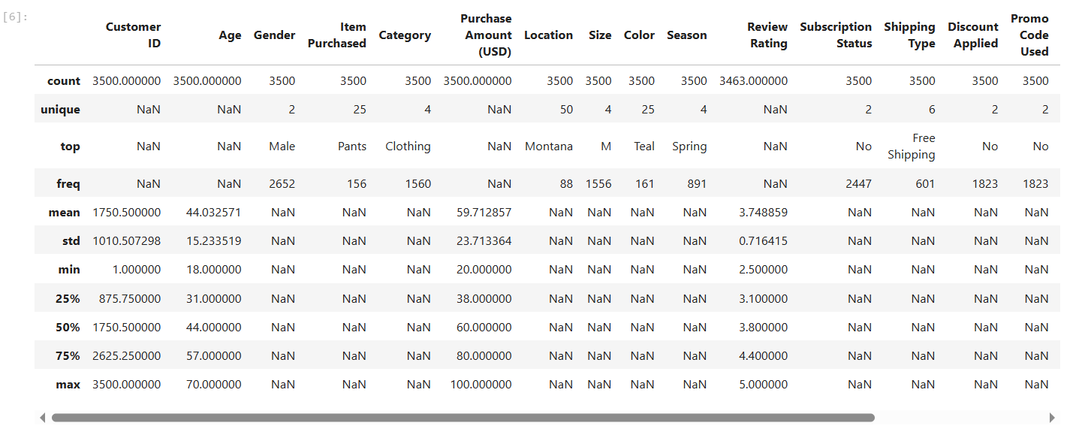
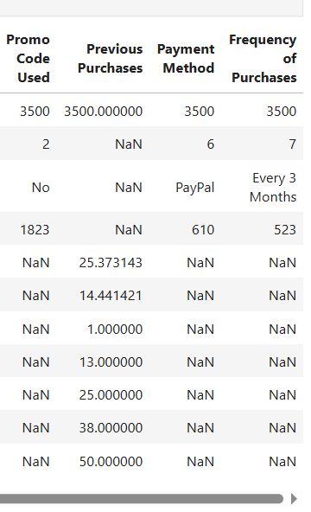

- Missing Data Handling: Checked for null values and imputed missing values in the
Review Rating column using the median rating of each product category.

- Column Standardization: Renamed columns to snake case for better readability and documentation.

- Feature Engineering:

  - Created age_group column by binning customer ages.
  - Created purchase_frequency_days column from purchase data.

- Data Consistency Check: Verified if discount_applied and promo_code_used
were redundant; dropped promo_code_used.

- Database Integration: Connected Python script to PostgreSQL and loaded the cleaned DataFrame into the database for SQL analysis.

Data Analysis using SQL (Business Transactions)
We performed structured analysis in PostgreSQL to answer key business questions:

- Revenue by Gender – Compared total revenue generated by male vs. female customers.

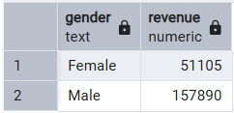

- High-Spending Discount Users – Identified customers who used discounts but still spent above the average purchase amount.

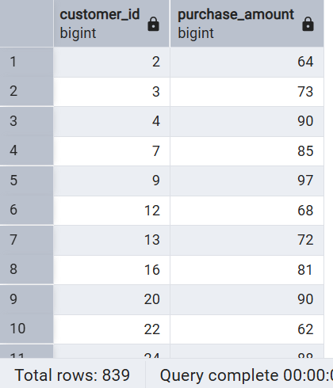

- Top 5 Products by Rating – Found products with the highest average review ratings.

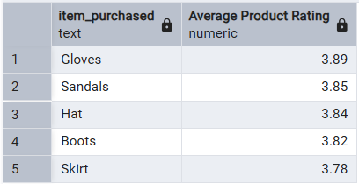

- Shipping Type Comparison – Compared average purchase amounts between Standard and Express shipping.
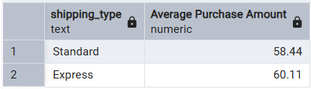

- Subscribers vs. Non-Subscribers – Compared average spend and total revenue across subscription status.
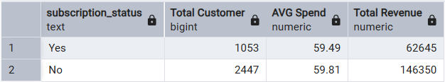

- Discount-Dependent Products – Identified 5 products with the highest percentage of discounted purchases.
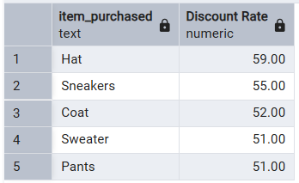

- Customer Segmentation – Classified customers into New, Returning, and Loyal segments based on purchase history.

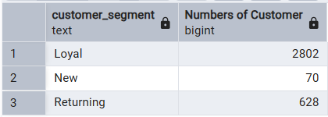

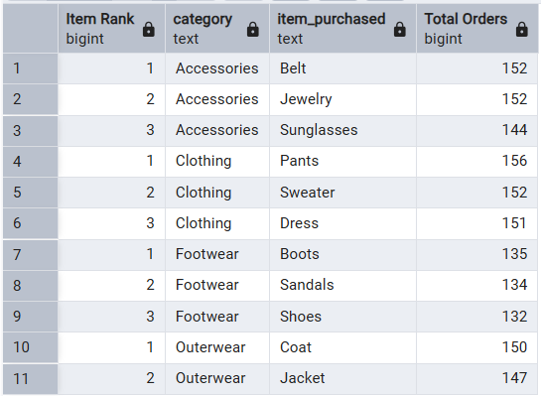
- Top 3 Products per Category – Listed the most purchased products within each category.

- Repeat Buyers & Subscriptions – Checked whether customers with >5 purchases are more likely to subscribe.
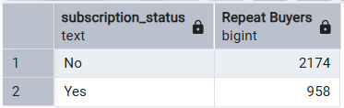

- Revenue by Age Group – Calculated total revenue contribution of each age group.

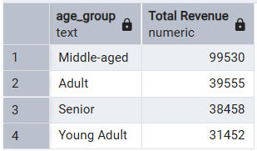

Dashboard in Power BI
Finally, we built an interactive dashboard in Power BI to present insights visually.
The primary Key Performance Indicators (KPIs) are:
- Total Revenue: $209K
- Number of Customers: 3.5K
- Average Purchase Amount: $59.71
- Average Review Rating: 3.75
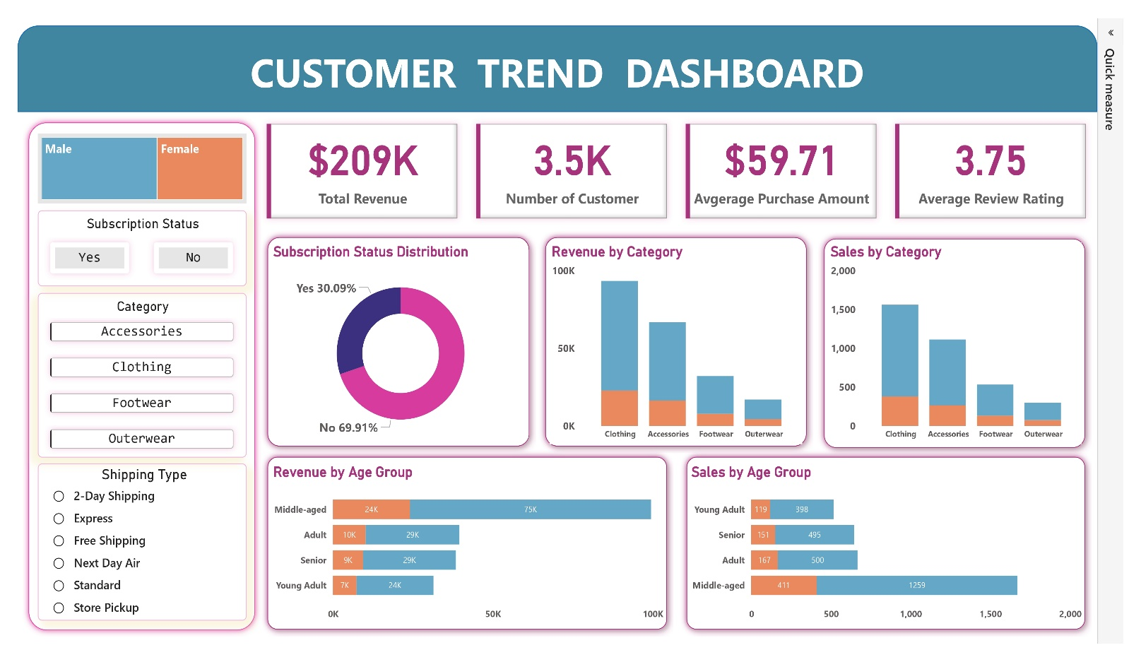
- Subscription Status Distribution: Yes - 30.09% | No - 69.91%

Business Recommendation

I. Strategic Business Recommendations
Based on the SQL query results, the following actions are the most impactful for revenue growth and margin control:

- Maximize Gender/Age Focus (Targeting):
  - Action: Invest in highly targeted marketing campaigns aimed at the Male segment and the Middle-aged group (highest revenue contributors).
  - Goal: Capitalize on the most valuable existing customer segments for maximum return on ad spend (ROAS).

- Address Discount-Dependency (Margin Control):
  - Action: Re-evaluate the discount strategy for high-volume, discount-dependent items like Hat (59.00% discount rate) and Sneakers (55.00% discount rate).
  - Goal: Protect profit margins by substituting deep discounts with value-added bundles or loyalty points.

- Optimize Loyalty Conversion (Retention):
- Action: Design targeted campaigns (e.g., email sequences, special offers) to convert the 628 Returning customers into the highly stable Loyal segment (2,802 customers).
- Goal: Increase the Customer Lifetime Value (CLTV) by moving repeat buyers into the most retained group.

❗️ NOTE ON SUBSCRIPTION DATA: The raw SQL data showed Non-Subscribers had a negligibly higher average spend ($59.81) than Subscribers ($59.49). The largest opportunity lies in converting the high volume of Non-Subscribers (69.91% of base).

II. Secondary Insights & Product Health

- Top Revenue Categories: The Clothing and Accessories categories are the highest revenue drivers.
- Top-Rated Products: Prominently feature top-rated products like Gloves (3.89 avg. rating) and Sandals (3.85 avg. rating) in marketing to build trust.

